**Assignment 3**

1)

create database Att;

use att;

create table attorney(

attorney_id int not null,

attorney_name varchar(15),

Attorney_street_address varchar(50),

Attorney_city varchar(10),

Attorney_state varchar(10),

Attorney_Zip_code int(5),

primary key(attorney_id)

);

create table Attorneybr(

Attorney_bar_Id int primary key,

Attorney_Id int,

foreign key(Attorney_Id) references attorney(Attorney_Id)

);

create table AttorneySPECIALITY(

Attorney_Id int ,

Attorney_speciality_Id int,

primary key(Attorney_speciality_Id),

foreign key(Attorney_Id) references attorney (Attorney_Id)

);

create table court(

Court_ID int not null,

Court_name varchar(15),

Court_city varchar(15),

Court_State varchar(10),

Court_Zipcode int(5),

primary key(Court_ID)

);

create table cases(

Case_Id int not null,

Court_ID int,

Case_Type varchar(50),

Case_Description varchar(100),

Primary key(Case_Id),

Foreign key(Court_ID) references court(Court_ID)

);

create table judge(

Judge_ID int not null primary key,

Judge_Name varchar(50),

Court_ID int,

Judge_years_in_practice int(3),

foreign key (Court_ID) references court(Court_ID)

);

create table clients(

Client_ID int not null,

Client_Name varchar(50),

Client_street_address varchar(30),

Client_city varchar(10),

Client_State varchar(10),

Client_Zip_code int(6),

Client_Phone int(10),

Client_DOB date,

primary key(Client_ID)

);

create table Client_dependent(

clientdependent_Id int primary key,

Dependent_name varchar(100),

Client_ID int,

foreign key (Client_ID) references clients(Client_ID)

);

create table Assignemnt(

Attorney_Id int,

case_id int,

client_id int,

Primary key(Attorney_id,case_id,client_id),

foreign key(Attorney_Id) references attorney(attorney_id),

foreign key(case_id) references cases(case_id),

foreign key(client_id) references clients(client_id)

);

insert into attorney(attorney_id,attorney_name,Attorney_street_address,Attorney_city,Attorney_state,Attorney_Zip_code) values (1,'attorney1','11,abc','aaa','state1',1234);

insert into attorney(attorney_id,attorney_name,Attorney_street_address,Attorney_city,Attorney_state,Attorney_Zip_code) values (2,'attorney2','12,def','bbb','state2',1235);

insert into attorney(attorney_id,attorney_name,Attorney_street_address,Attorney_city,Attorney_state,Attorney_Zip_code) values (3,'attorney3','13,ghi','ccc','state3',1236);

insert into attorney(attorney_id,attorney_name,Attorney_street_address,Attorney_city,Attorney_state,Attorney_Zip_code) values (4,'attorney4','14,jkl','ddd','state4',1237);

insert into Attorneybr(Attorney_Bar_Id,attorney_id)values (11,1);

insert into Attorneybr(Attorney_Bar_Id,attorney_id)values (22,2);

insert into Attorneybr(Attorney_Bar_Id,attorney_id)values (33,3);

insert into Attorneybr(Attorney_Bar_Id,attorney_id)values (44,4);

insert into AttorneySPECIALITY(Attorney_speciality_Id,attorney_id) values(111,1);

insert into AttorneySPECIALITY(Attorney_speciality_Id,attorney_id) values(222,2);

insert into AttorneySPECIALITY(Attorney_speciality_Id,attorney_id) values(333,3);

insert into AttorneySPECIALITY(Attorney_speciality_Id,attorney_id) values(444,4);

insert into court(court_id,Court_name,Court_city,Court_State,Court_Zipcode) values(1111,'court1','city1','state1',123);

insert into court(court_id,Court_name,Court_city,Court_State,Court_Zipcode) values(2222,'court2','city2','state2',456);

insert into court(court_id,Court_name,Court_city,Court_State,Court_Zipcode) values(3333,'court3','city3','state3',789);

insert into court(court_id,Court_name,Court_city,Court_State,Court_Zipcode) values(4444,'court4','city4','state4',124);

insert into cases(case_id,Court_ID,Case_Type,Case_Description) values(11111,1111,'a','abcd ef gh');

insert into cases(case_id,Court_ID,Case_Type,Case_Description) values(22222,2222,'b','ijkl jk kl');

insert into cases(case_id,Court_ID,Case_Type,Case_Description) values(33333,3333,'c','abcd gh ji');

insert into cases(case_id,Court_ID,Case_Type,Case_Description) values(44444,4444,'d','abhj gf yu');

insert into judge(judge_id,Judge_Name,court_id,Judge_years_in_practice) values(11,'judge1',1111,7);

insert into judge(judge_id,Judge_Name,court_id,Judge_years_in_practice) values(12,'judge2',2222,8);

insert into judge(judge_id,Judge_Name,court_id,Judge_years_in_practice) values(13,'judge3',3333,9);

insert into judge(judge_id,Judge_Name,court_id,Judge_years_in_practice) values(14,'judge4',4444,6);

insert into clients(client_id,Client_Name,Client_street_address,Client_city,Client_State,Client_Zip_code,Client_Phone,Client_DOB) values (21,'clientname1','11,abcd','city1','state1','1234','1234567890','2001-1-1');

insert into clients(client_id,Client_Name,Client_street_address,Client_city,Client_State,Client_Zip_code,Client_Phone,Client_DOB) values (22,'clientname2','12,bade','city2','state2','4567','1234567891','2002-2-2');

insert into clients(client_id,Client_Name,Client_street_address,Client_city,Client_State,Client_Zip_code,Client_Phone,Client_DOB) values (23,'clientname3','13,abhd','city3','state3','8906','1234567892','2003-3-3');

insert into clients(client_id,Client_Name,Client_street_address,Client_city,Client_State,Client_Zip_code,Client_Phone,Client_DOB) values (24,'clientname4','12,bafgh','city4','state4','5647','1234567894','2004-4-4');

insert into Client_dependent(clientdependent_Id,Dependent_name,Client_ID)values(31,'dependent1',21);

insert into Client_dependent(clientdependent_Id,Dependent_name,Client_ID)values(32,'dependent1',22);

insert into Client_dependent(clientdependent_Id,Dependent_name,Client_ID)values(33,'dependent1',23);

insert into Client_dependent(clientdependent_Id,Dependent_name,Client_ID)values(34,'dependent1',24);

insert into Assignemnt(Attorney_Id,case_id,client_id )values(1,11111,21);

insert into Assignemnt(Attorney_Id,case_id,client_id )values(2,22222,22);

insert into Assignemnt(Attorney_Id,case_id,client_id )values(3,33333,23);

insert into Assignemnt(Attorney_Id,case_id,client_id )values(4,44444,24);

2)

SELECT * FROM att.assignemnt;

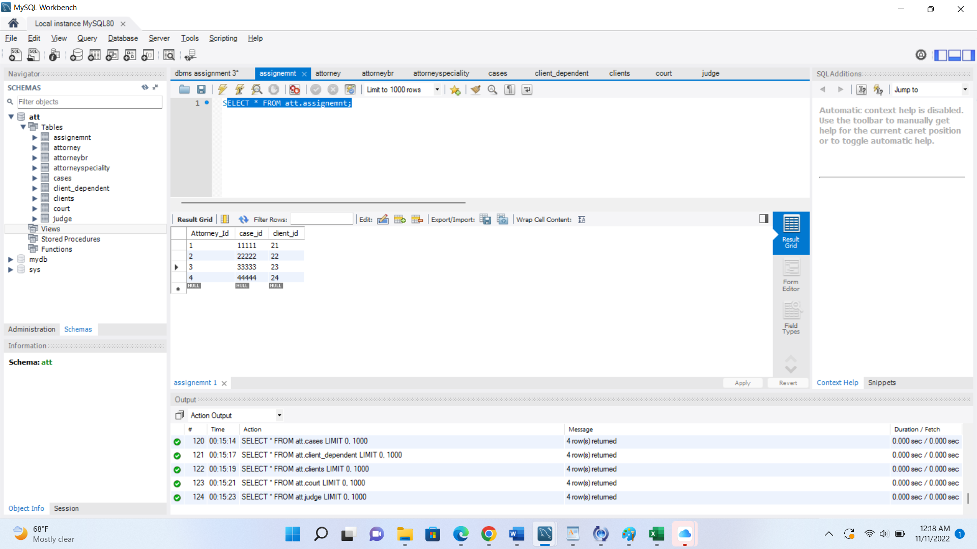

SELECT * FROM att.attorney;

SELECT * FROM att.attorneybr;

SELECT * FROM att.attorneyspeciality;

SELECT * FROM att.cases;

SELECT * FROM att.client_dependent;

SELECT * FROM att.clients;

SELECT * FROM att.court;

SELECT * FROM att.judge;

